SPRING 2025
COMP 302
KU Tower Defense
D1

TeamD
Ahmet Taha Ekim - 79234
Muhammed Talha Sarıtepe - 79264
Mert Tuna – 80363
Doğu Arslan – 76649
Emir Göcen – 79634

Table of Contents
Logical Architecture 3
- Package Diagram 3
- Extended Package Diagram 3
- Current Code Package Diagram 4
Sequence Diagrams 5
- SD 1: Tower Manager 5
- SD 2: Save Level 6
- SD 3: Render Pipeline 7
- SD 4: Projectile Manager 8
- SD 5: Mouse Clicked 9
- SD 6: Main Menu 10
- SD 7: Load Sprite 11
- SD 8: Load Level 12
- SD 9: Run Game 13
- SD 10: Main Game 14
- SD 11: Enemy Manager 15
- SD 12: Tile Editing 16
- SD 13: Render Editing Mode 17
- SD 14: Click Button 18
Communication Diagrams 19
- CD 1: Tower Manager 19
- CD 2: Save Level 19
- CD 3: Render Pipeline 20
- CD 4: Projectile Manager 20
- CD 5: Mouse Clicked 21
- CD 6: Main Menu 22
  - CD 6A: Main Menu Construction. . . . . . . . . . . . . . . . . . . . . . . . . . . . . . . . . . 22
  - CD 6B: Main Executable. . . . . . . . . . . . . . . . . . . . . . . . . . . . . . . . . . . . . . . . 22
- CD 7: Load Sprite 23
- CD 8: Load Level 23
- CD 9: Run Game 24
- CD 10: Main Game 24
- CD 11: Enemy Manager 25
- CD 12: Tile Editing 25
- CD 13: Render Editing Mode 26
- CD 14: Click Button 26
Class Diagram 27

Logical Architecture
***In R2M2, there is the final Package Diagram for Logical Architecture.

UML Package Diagram:
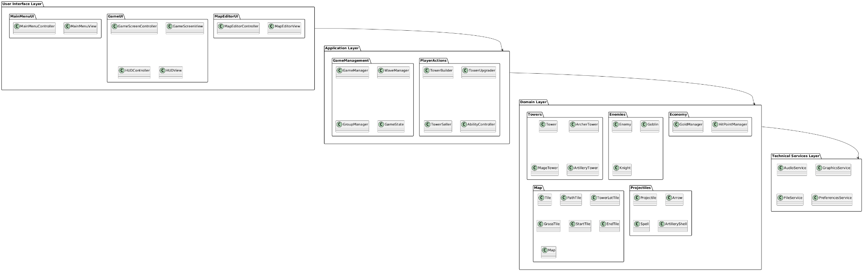

Figure 1: UML Package Diagram

Extended Package Diagram:
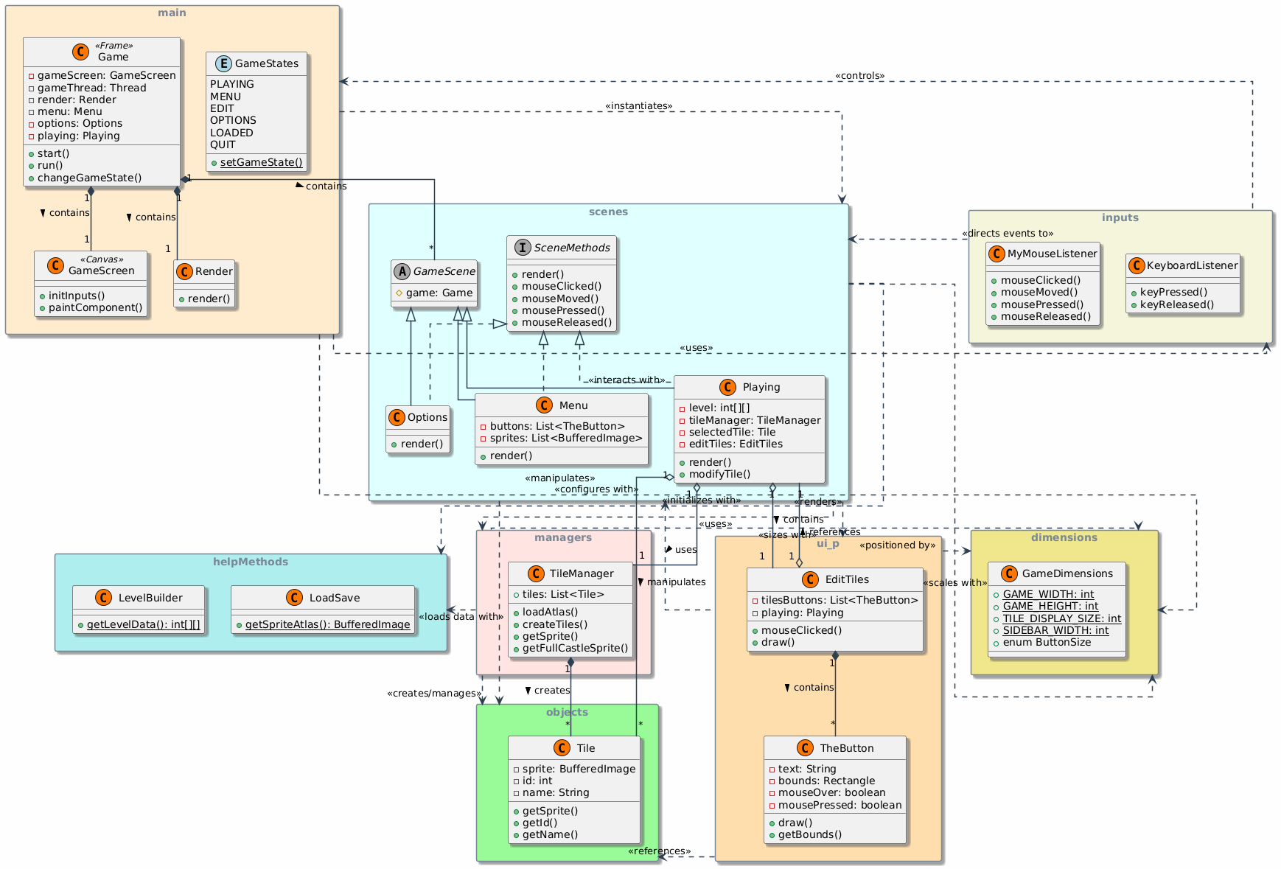
Figure 2: Extended Package Diagram

Current Code Package Diagram:

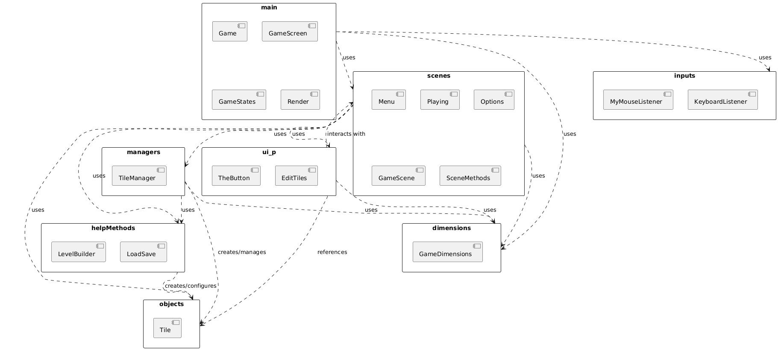
Figure 3: Current Code Package Diagram

Sequence Diagrams

SD 1: Tower Manager

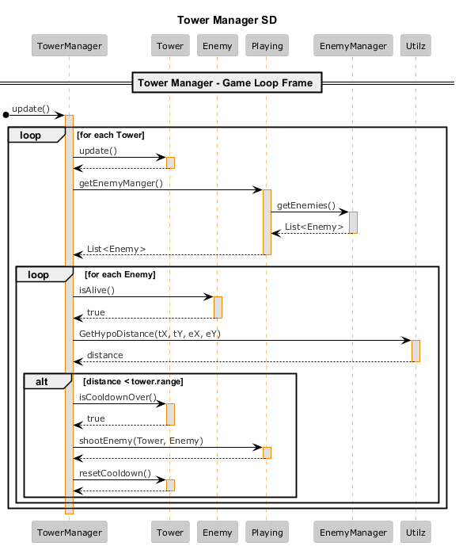

Figure 4: Tower Manager Sequence Diagram

SD 2: Save Level

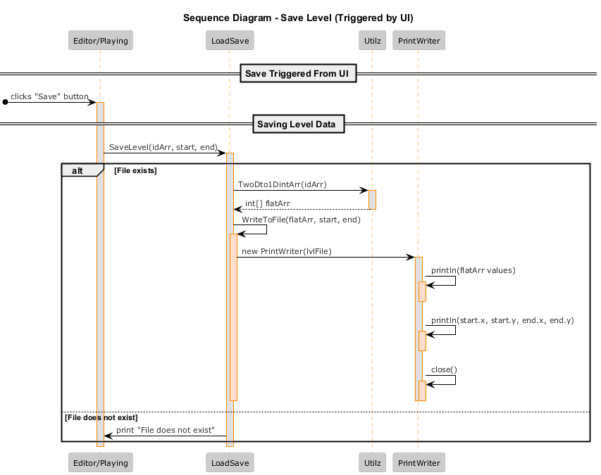

Figure 5: Save Level Sequence Diagram

SD 3: Render Pipeline

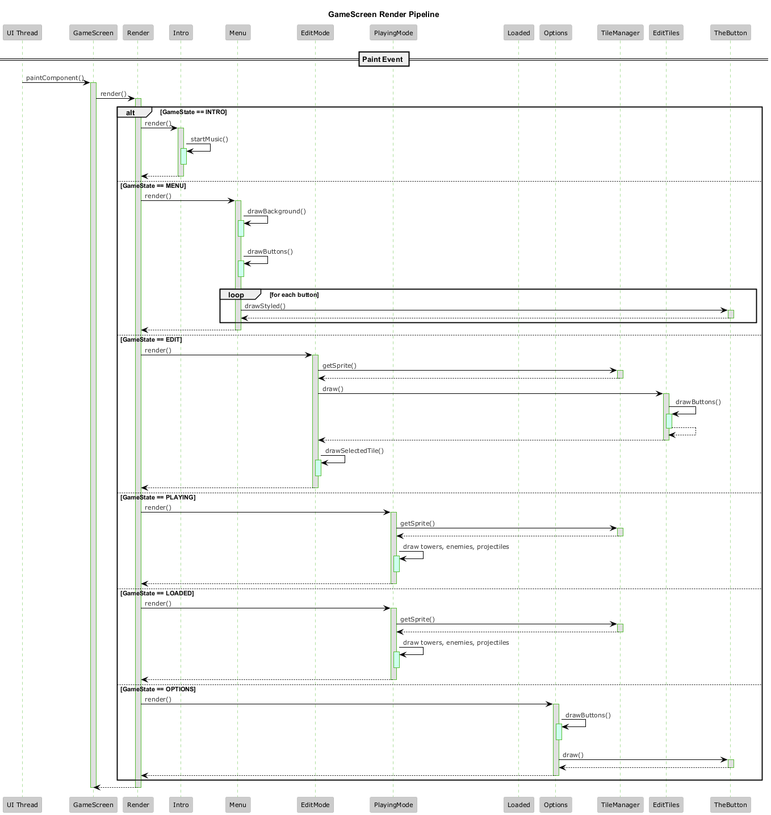
Figure 6: Render Pipeline Sequence Diagram

SD 4: Projectile Manager

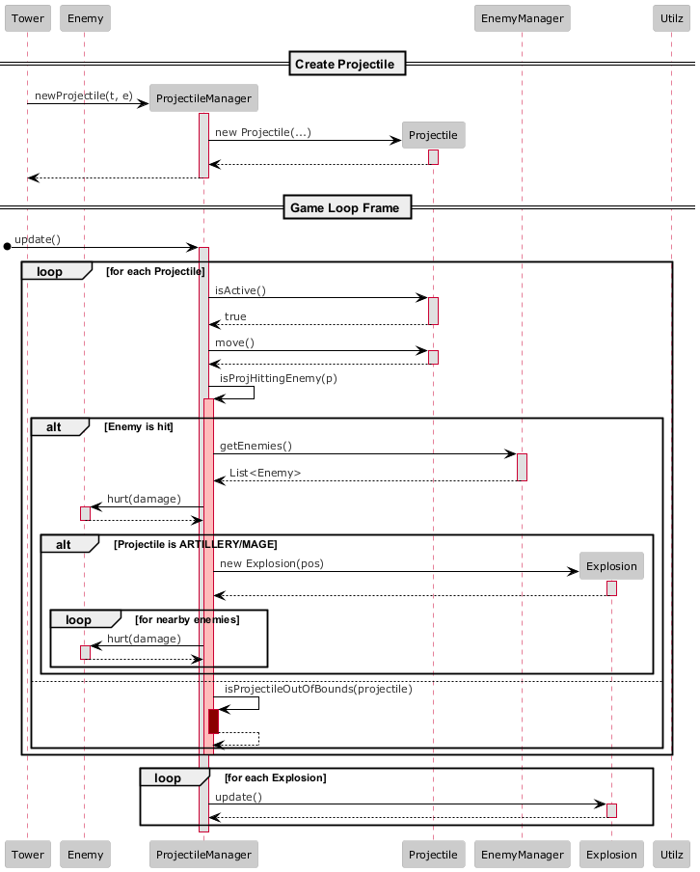

Figure 7: Projectile Manager Sequence Diagram

SD 5: Mouse Clicked

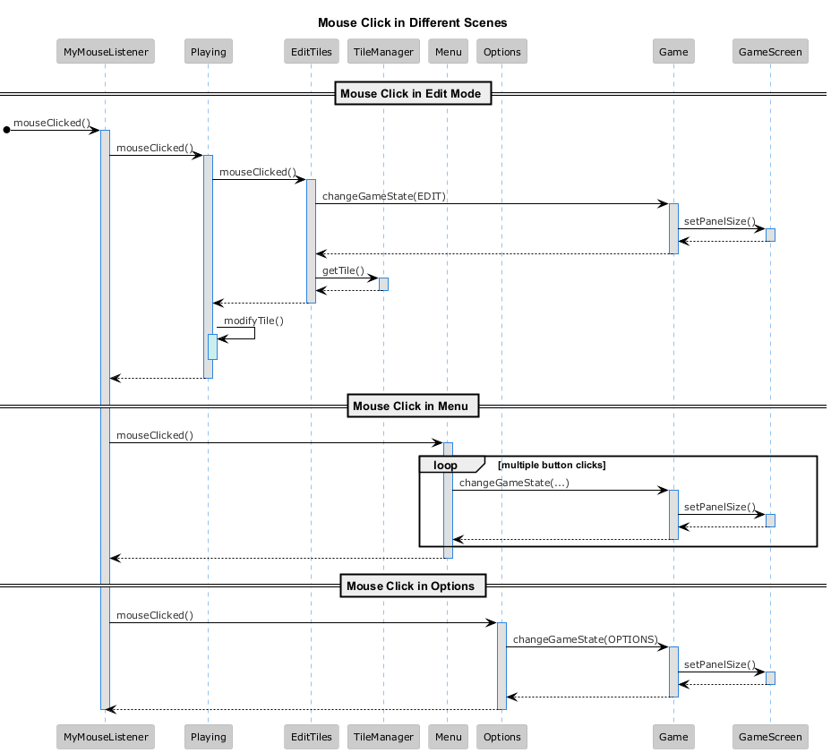

Figure 8: Mouse Clicked Sequence Diagram

SD 6: Main Menu

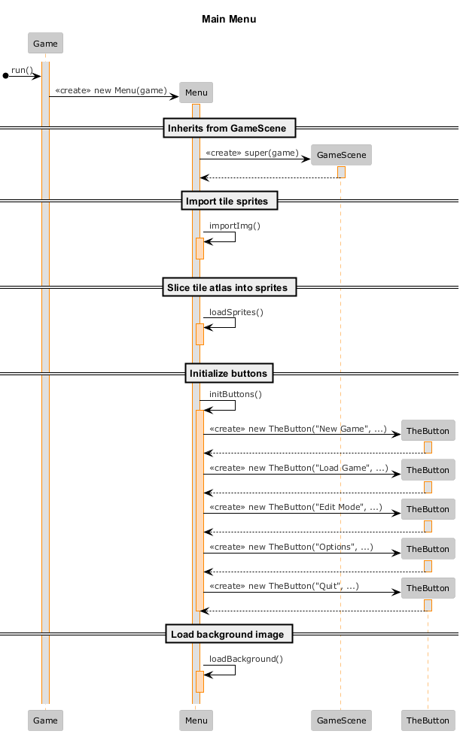

Figure 9: Main Menu Sequence Diagram

SD 7: Load Sprite

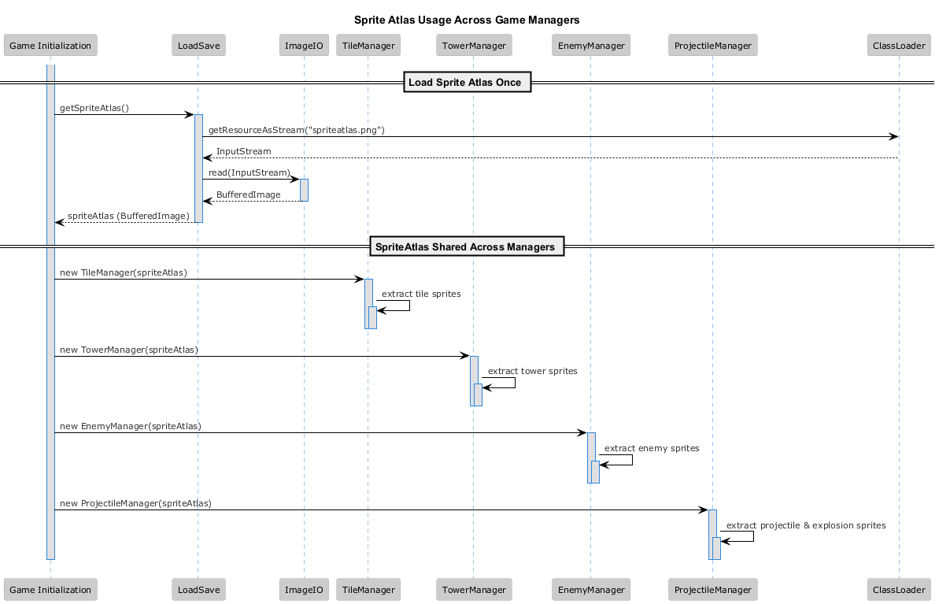

Figure 10: Load Sprite Sequence Diagram

SD 8: Load Level

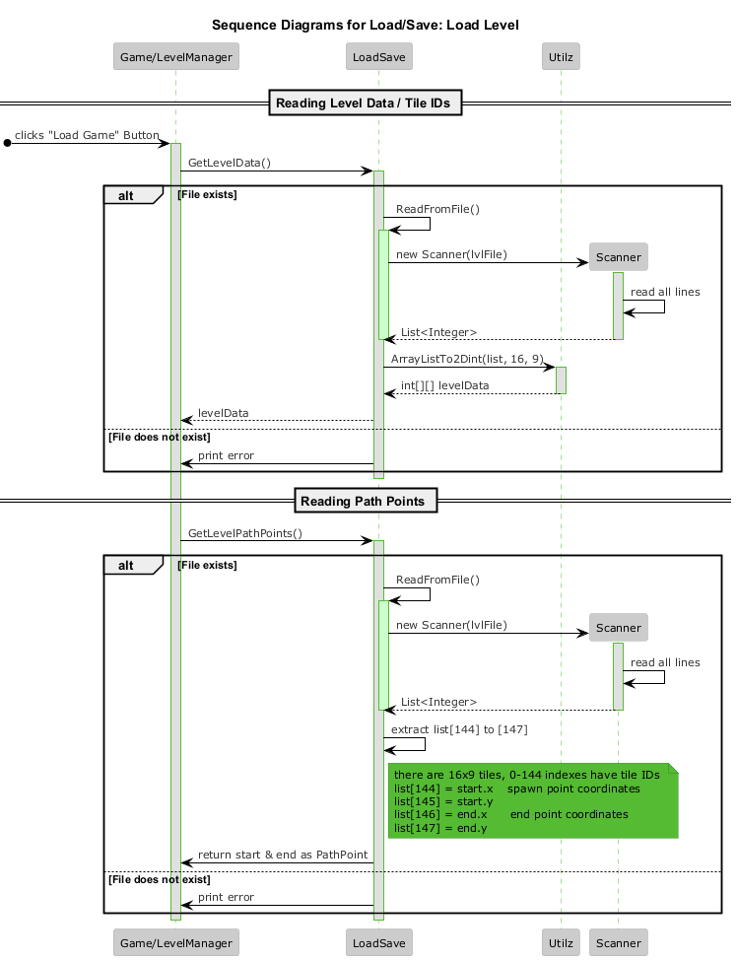

Figure 11: Load Level Sequence Diagram

SD 9: Run Game

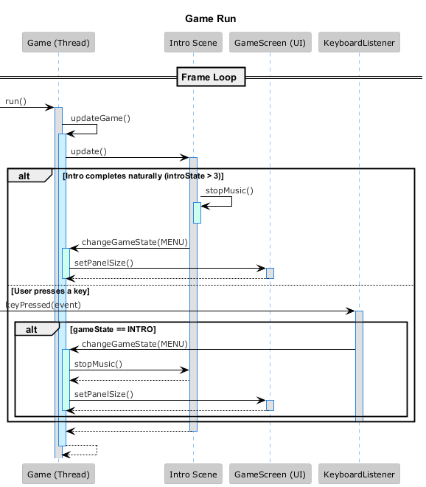

Figure 12: Run Game Sequence Diagram

SD 10: Main Game

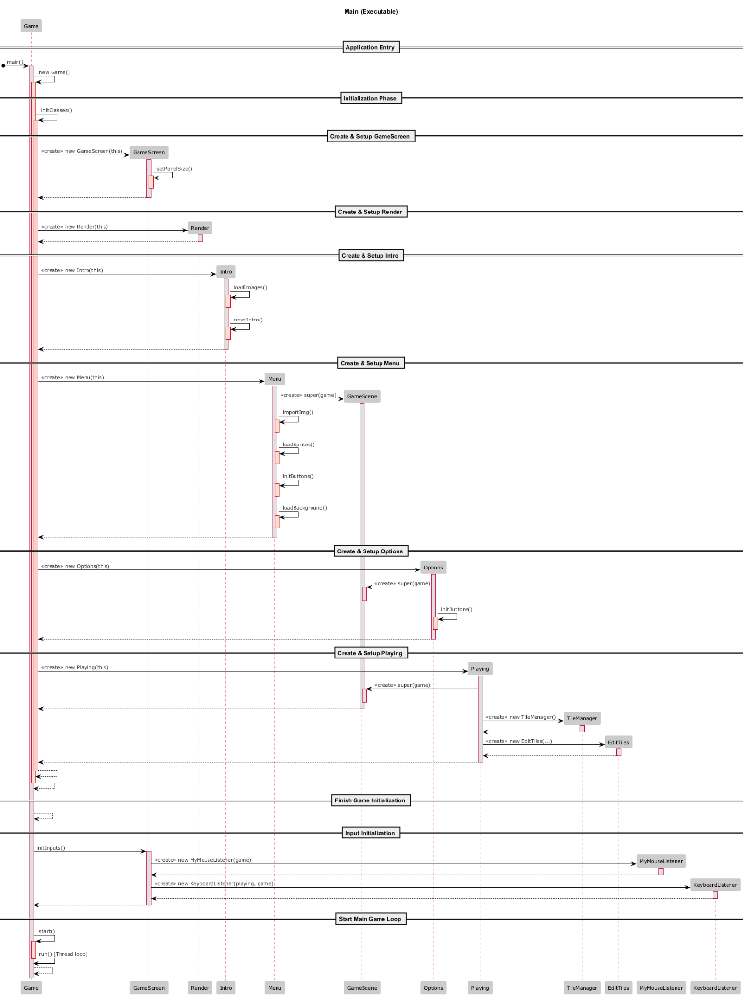

Figure 13: Main Game Sequence Diagram
SD 11: Enemy Manager

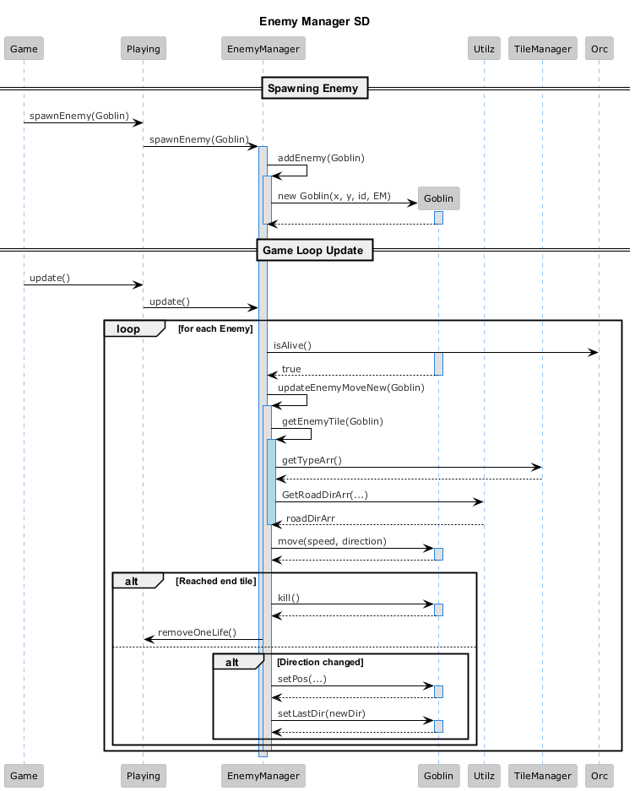

Figure 14: Enemy Manager Sequence Diagram

SD 12: Tile Editing

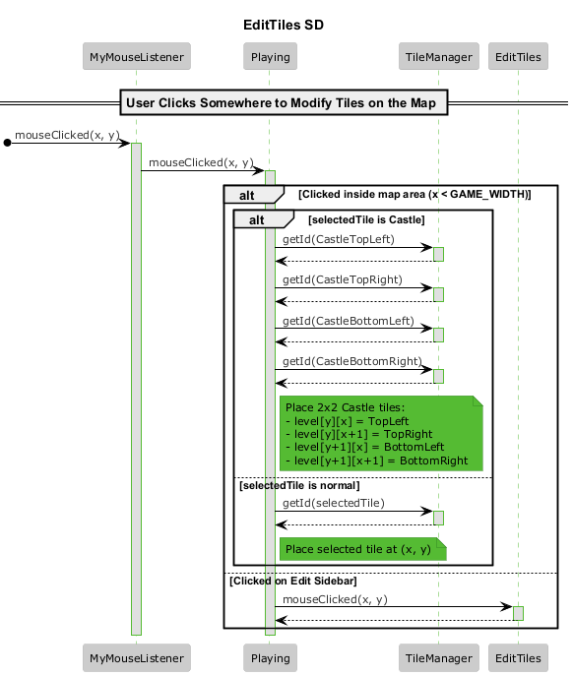

Figure 15: Tile Editing Sequence Diagram

SD 13: Render Editing Mode

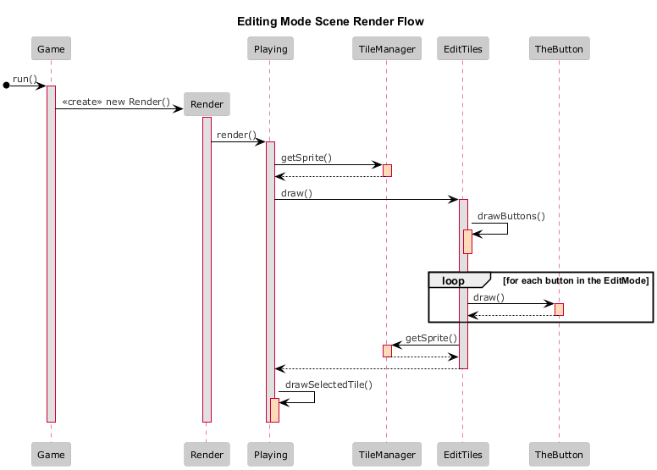

Figure 16: Render Editing Mode Sequence Diagram

SD 14: Click Button

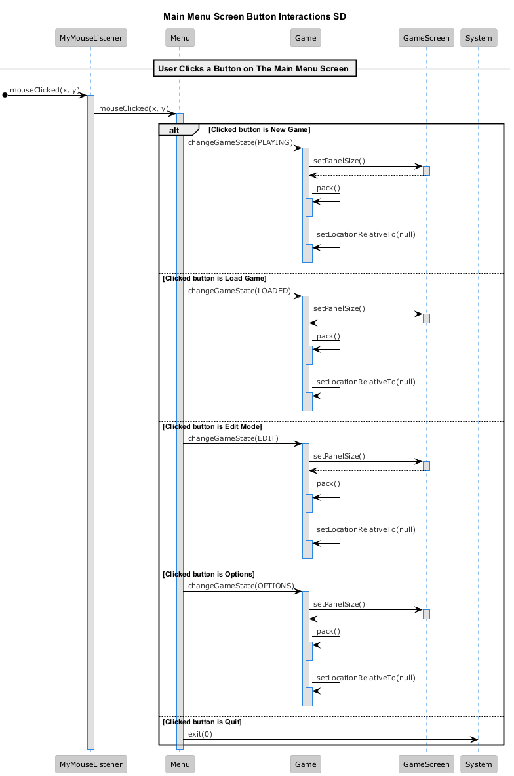

Figure 17: Click Button Sequence Diagram

Communication Diagrams

CD 1: Tower Manager

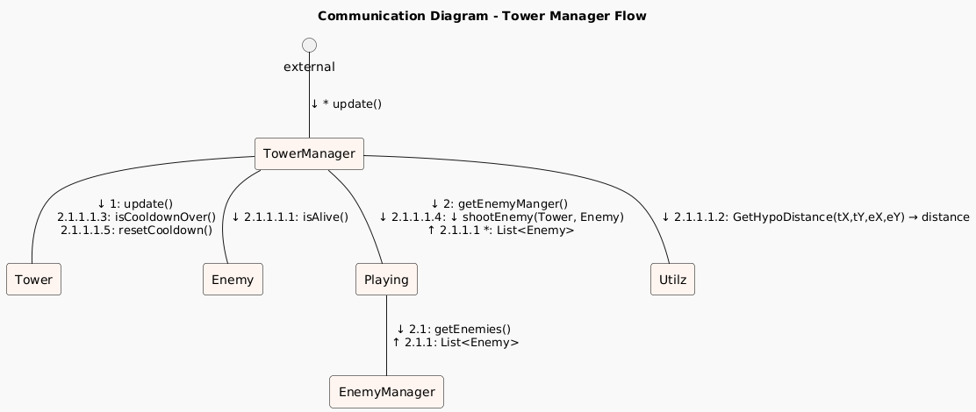

Figure 18: Tower Manager Communication Diagram

CD 2: Save Level

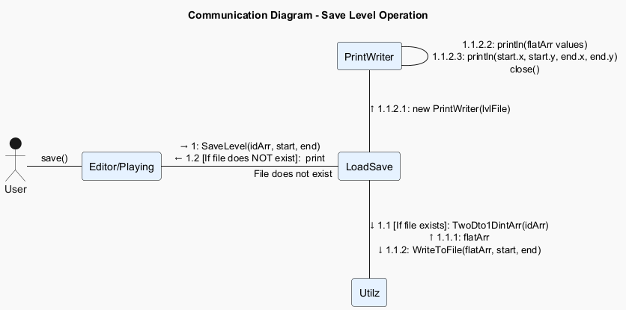

Figure 19: Save Level Communication Diagram

CD 3: Render Pipeline

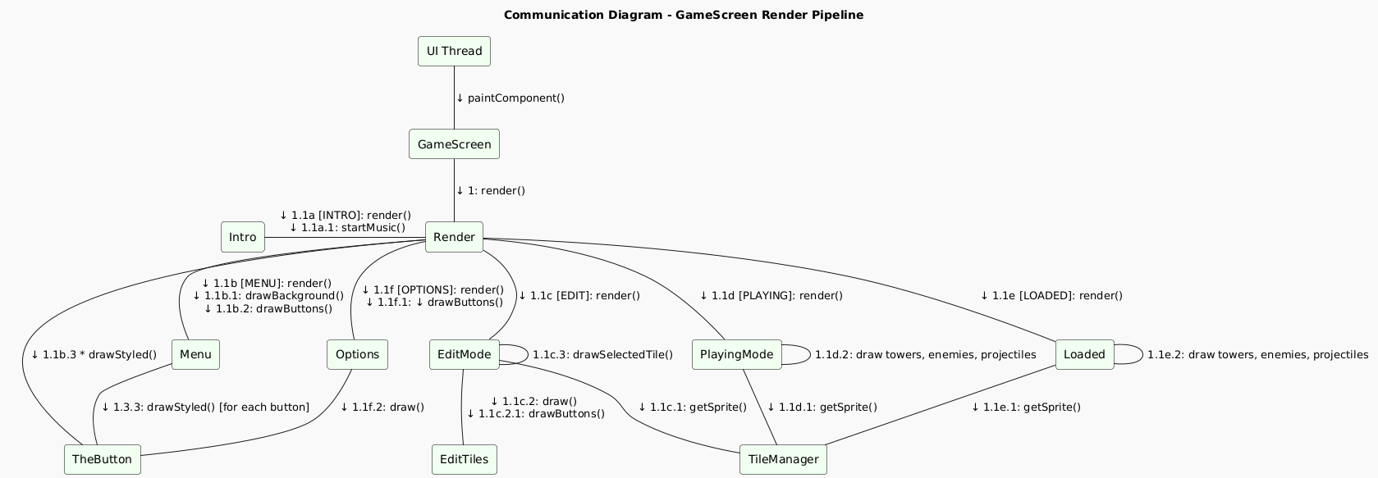

Figure 20: Render Pipeline Communication Diagram

CD 4: Projectile Manager

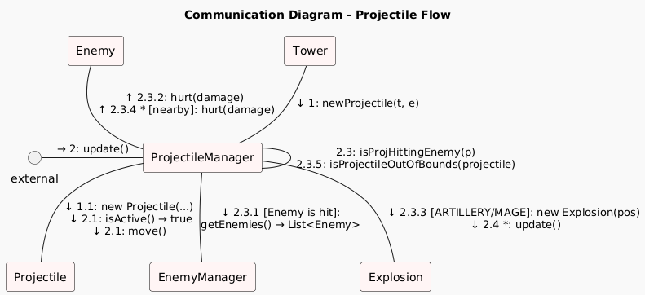

Figure 21: Projectile Manager Communication Diagram

CD 5: Mouse Clicked

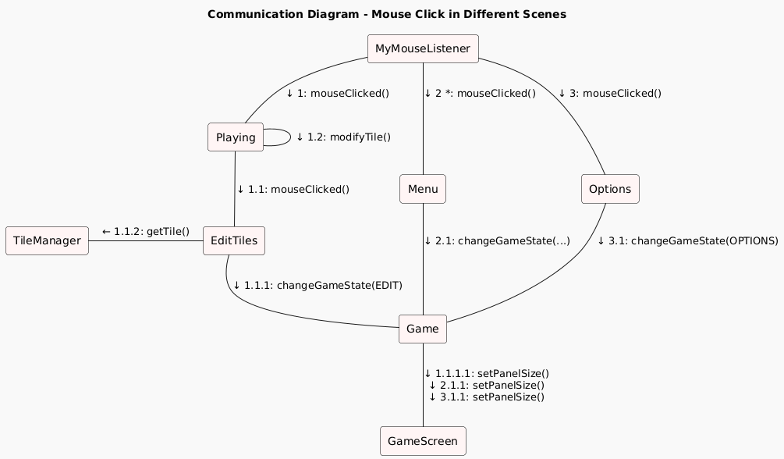

Figure 22: Mouse Clicked Communication Diagram

CD 6: Main Menu

- CD 6A: Main Menu Construction
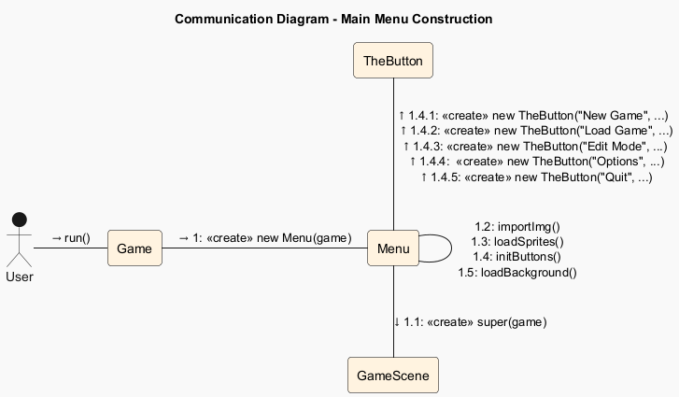

Figure 23: Main Menu Construction Communication Diagram

- CD 6B: Main Executable

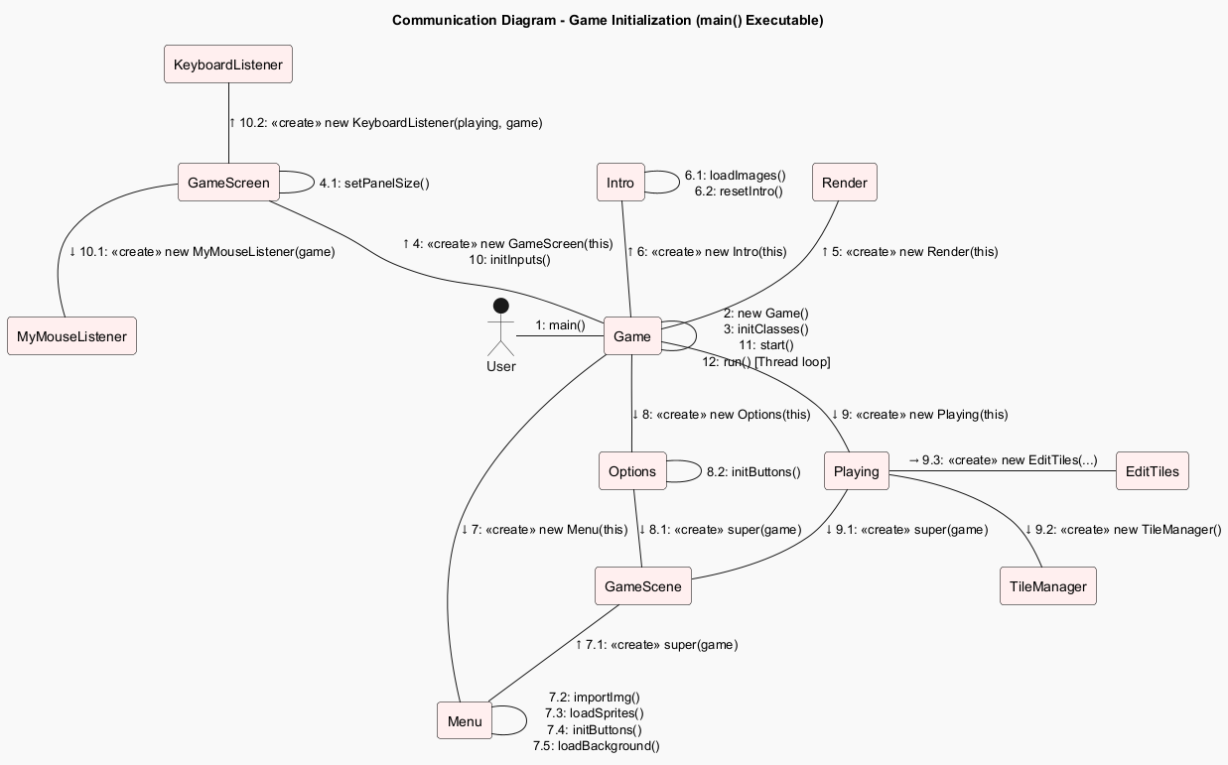

Figure 24: Main Executable Communication Diagram
CD 7: Load Sprite

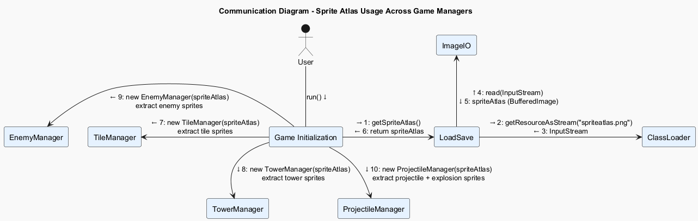
Figure 25: Load Sprite Communication Diagram

CD 8: Load Level

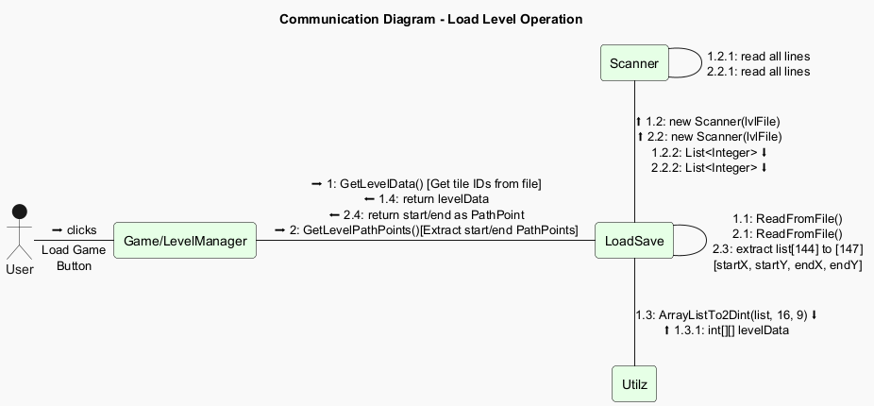

Figure 26: Load Level Communication Diagram

CD 9: Run Game

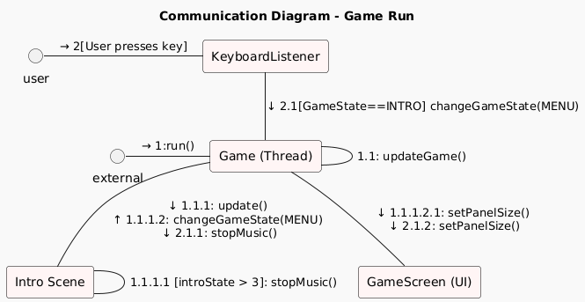

Figure 27: Run Game Communication Diagram

CD 10: Main Game

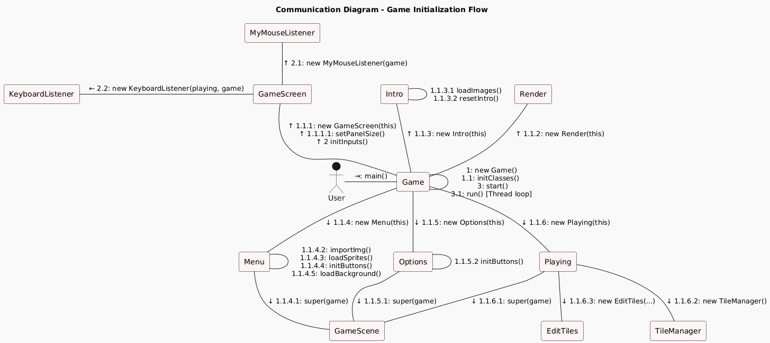

Figure 28: Main Game Communication Diagram

CD 11: Enemy Manager

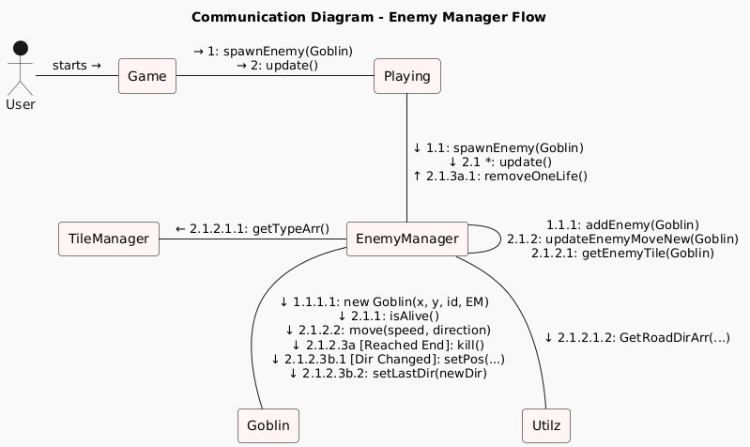

Figure 29: Enemy Manager Communication Diagram

CD 12: Tile Editing

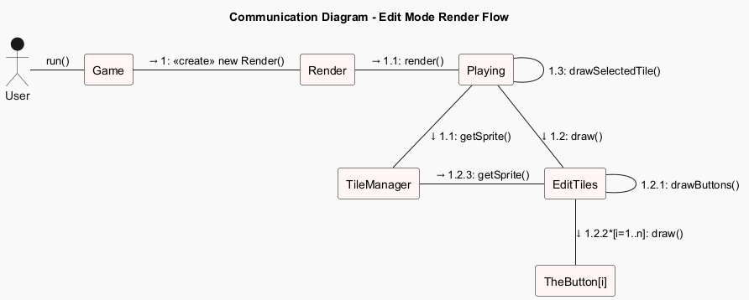

Figure 30: Tile Editing Communication Diagram

CD 13: Render Editing Mode

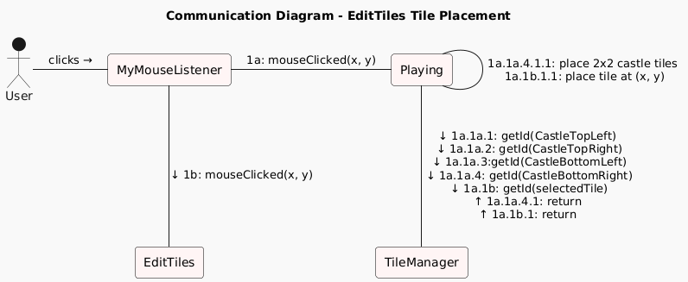

Figure 31: Render Editing Mode Communication Diagram

CD 14: Click Button

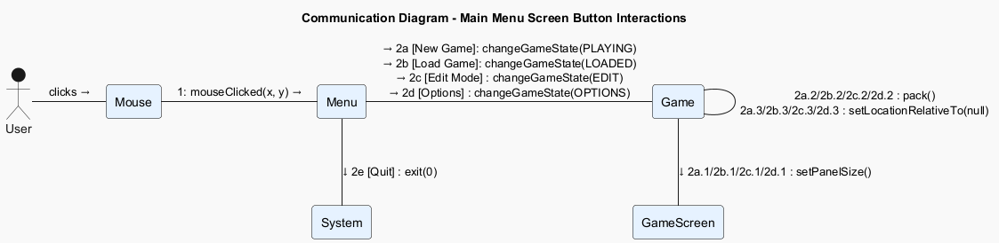

Figure 32: Click Button Communication Diagram

Class Diagram

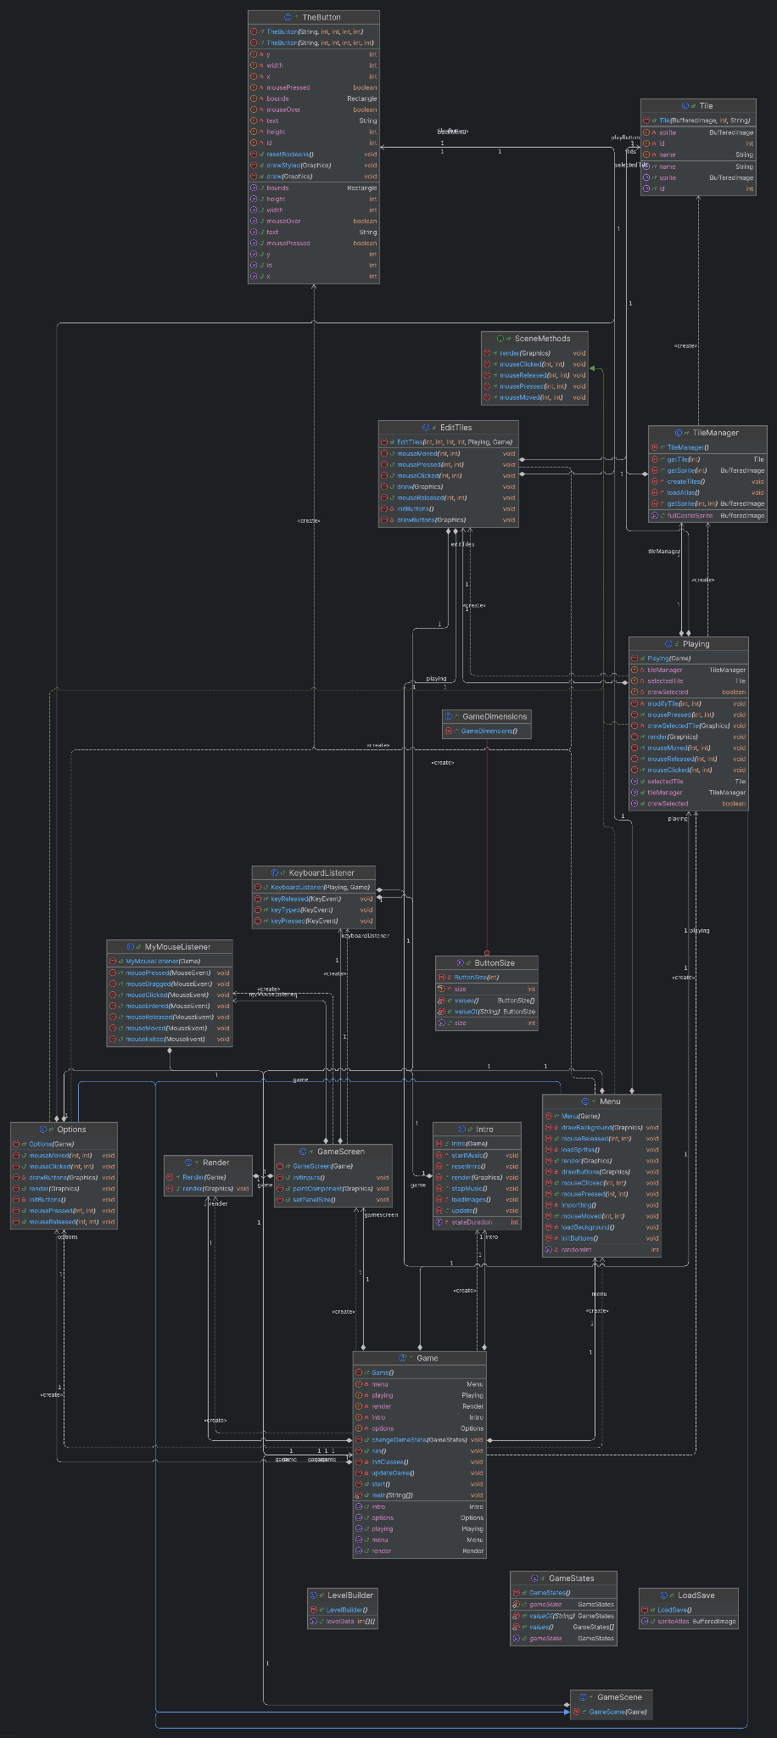

Figure 33: Class Diagram

